11.44: The simplest way to do this is to consider the changes in the forces due to the extra weight of the box. Taking torques about the rear axle, the force on the front wheels is decreased by  so the net force on the front wheels is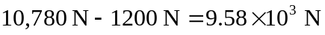to three figures. The weight added to the rear wheels is then 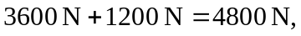 so the net force on the rear wheels is 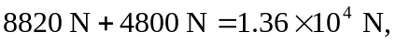 again to three figures.
b) Now we want a shift of 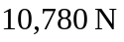 away from the front axle. Therefore, 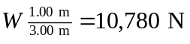 and so 